**FINANCIAL AND INDIVIDUAL FUTURE EXPENSE**

**PREDICTION BASED ON FREQUENT PATTERN**

**A PROJECT REPORT**

**Submitted by**

**SOWNDAPAN M V 312316205153**

**VIJAY M 312316205182**

# in partial fulfillment for the award of the degree of

**BACHELOR OF TECHNOLOGY**

**in**

**INFORMATION TECHNOLOGY**



**St.JOSEPH’S COLLEGE OF ENGINEERING, CHENNAI 600119**

**ANNA UNIVERSITY: CHENNAI 600 025**

**MARCH 2020**

# ANNA UNIVERSITY: CHENNAI 600 025



**BONAFIDE CERTIFICATE**

Certified that this project report “Financial and Individual Expense Prediction based on Frequent Pattern**”**​is​ the bonafide work of **SOWNDAPAN.M.V**​ **(312316205153)** and​ **VIJAY.M**​ **(312316205182)** who​ carried out the project work under my supervision, for the partial fulfilment of the requirements for the award of the degree of Bachelor of Technology in Information Technology.

|  |  |
| --- | --- |
| **SIGNATURE** | **SIGNATURE** |
| Dr. V.Muthulakshmi M.E., Ph.D. | Ms. M.Anbu M.E. |
| Professor Associate Professor | Associate Professor |
| **HEAD OF THE DEPARTMENT** | **SUPERVISOR** |
| Department of | Department of |
| Information Technology | Information Technology |
| St.Joseph’s College of Engineering | St.Joseph’s College of |
| Engineering Old Mamallapuram Road | Old Mamallapuram Road |
| Chennai- 600119 | Chennai- 600119 |

Submitted for the Viva -Voce held on

**(INTERNAL EXAMINER) (EXTERNAL EXAMINER)**

**ii**​

# CERTIFICATE OF EVALUATION

**College Name :** St.Joseph’s College of Engineering

**Branch & Semester :** Information Technology

|  |  |  |  |
| --- | --- | --- | --- |
| **S.NO** | **NAME OF THE**  **STUDENTS** | **TITLE OF THE**  **PROJECTS** | **NAME OF THE**  **SUPERVISOR WITH**  **DESIGNATION** |
| 1.    2. | SOWNDAPAN M V    VIJAY M | Financial and Individual  Expense Prediction based on Frequent  Pattern | Ms.M.ANBU M.E    Associative Professor  St.Joseph’s College of  Enginnering |

The report of the project work submitted by the above students in partial fulfillment for the award of Bachelor of Technology degree in Information Technology of Anna University were evaluated and confirmed to be reports of the work done by the above students.

**(INTERNAL EXAMINER) (EXTERNAL EXAMINER)**

**iii**​

# ACKNOWLEDGEMENT

The contentment and elation that accompany the successful completion of any work be incomplete without mentioning the people who made it possible.

We express our gratitude in thanking our Chairman and Managing

# Director Dr.​ B.Babu Manoharan M.A., M.B.A., Ph.D., our​ respected Director

Madam **Mrs.**​ **B.Jessie Priya M.Com.,** our​ Director Sir **Mr.B.Shashi**​ **Sekar M.Sc.,**our​ respected Principal **Dr.Vaddi**​ **Seshagiri Rao M.E., M.B.A., Ph.D** for having encouraged us to do our under graduation in Information Technology in this esteemed college.

We express our sincere thanks and most heartfelt sense of gratitude to our eminent Head of the Department **Dr.**​ **V.Muthulakshmi M.E., Ph.D.,** for​ having extended her helping hand at all times.

It is with a deep sense of gratitude that we acknowledge our indebtedness to our supervisor **MS.M.Anbu**​a​ perfectionist for her expert guidance and connoisseur suggestion.

Last but not the least, we thank our family members and friends who have been the greatest source of support to us.

iv​

# ABSTRACT

Modern life offers a plethora of options of services and goods for consumers. As a result, people’s expenses have gone up dramatically, compared to a decade ago, and the cost of living has been increasing day by day. Thus it becomes essential to keep a check on expenses in order to live a good life with a proper budget set up.

This application allows users to track their expenses daily, weekly, monthly, and yearly in terms of summary, bar graphs, and pie-charts. This application is both web and mobile, a full detailed expense tracker tool that will not only help users keep a check on their expenses, but also cut down the unrequited expenses, and thus will help provide a responsible lifestyle. An analysis comparing existing expense tracking software with the one being introduced is provided. Penny, the Expense Tracker Mobile Application was developed for users to keep track of their expenses and determine whether they are spending as per their set budget. Potential users need to input the required data such as the expense amount, merchant, category, and date when the expense was made. Optional data such as sub-category and extra notes about the expense can be entered as well.

v

​

# TABLE OF CONTENTS

**CHAPTER TITLE PAGE NO.**

**ABSTRACT** ​ V​

**LIST OF FIGURES** ​ VII​

**LIST OF ABBREVIATIONS**​ VIII​

## 1 INTRODUCTION

1.1 NEED FOR EXPENSE TRACKER APPLICATION 1

1.2 CORE APPLICATION OBJECTS 2

1.3 APPLICATION OVERFLOW 2

1.4 AGILE MODEL 3

1.5 DESIGN AND DEVELOPMENT 3

1.6 CHALLENGES IN DEVELOPMENT 3

1.7 ADVANTAGES OVER ALGORITHM 4

1.8 TECHNOLOGIES TO OVERCOME CHALLENGES 4

## 2 SOFTWARE LEVEL DESIGN​

2.1 LINEAR REGRESSION 5

2.2 APRIORI ALGORITHM 6

2.2.1 APRIORI PROPERTY 6

2.3 REQUIREMENTS 8

2.3.1 FUNCTIONAL 8

2.3.2 NON-FUNCTIONAL 8

1. **LITERATURE SURVEY** ​ 9​
2. **SYSTEM DESIGN** ​ 13
3. **REFERENCES** ​ 18​

vi​

**LIST OF FIGURES**

# FIGURE NO NAME OF THE FIGURE PAGE NO

1.1 ReactJS and NodeJS Workflow 2

3.1 Regression chart for Expense prediction 5

3.2 Item Data set. 6

6.1 Architecture Diagram 13

6.2 User Interaction with Application. 14

6.3 Use case Diagram 15

6.4 Mobile View 16

6.5 LapTop View 17

**LIST OF ABBREVIATIONS**

# ACRONYM EXPLANATION

**IDE**​ INTEGRATED DEVELOPMENT ENVIRONMENT

**SDK** SOFTWARE DEVELOPMENT KIT

**UI** USER INTERFACE

**OS** OPERATING SYSTEM

**HTML** HYPERTEXT MARKUP LANGUAGE

**CSS**  CASCADING STYLE SHEETS

**PC** PERSONAL COMPUTER

**MERN** MONGODB, EXPRESS, REACT, NODEJS

vii

​

**CHAPTER 1**

## INTRODUCTION

Expenses tracker applications comprise various different categories such as Entertainment, Sports, Lifestyle, Education, Games, Food and Drink, Health and Fitness, Finance, etc. This application falls in the Finance Category and serves the important purpose of managing finances which is a very important part of one’s life. The software product went through the design, development, and the testing phase as a part of the Software Development Life cycle. The application’s interface is designed using custom art elements, the functionality

is implemented using SDK, and the phase of testing the product was accomplished successfully. The application comprises of having user enter the expense amount, date,

category, merchant and other optional attributes, With this entered information, the user is able to see the expense details daily, weekly, monthly, and yearly in figures, graphs, PDF format, and can print them as well if a printer is detected or scanned nearby. All these topics have been explained in detail in their respective chapters. The aim of this thesis is to provide a solution for users on how to manage finances in any circumstance by keeping track of their expenses

every day. Ultimately, this contributes to societal well-being.

1.1 NEED FOR EXPENSE TRACKER APPLICATION

The sole reason behind the need for this application is that when you start finding out where you are spending your money, it becomes easy to figure out how you can save money by cutting back or even eliminating spending in some areas. Mental Budgeting leads people to over consume some goods .Because budgets are set before consumption opportunities arise, they sometimes overestimate or underestimate the money required for a particular amount. On the other hand, expense tracking shows that some expenses are more likely to produce over-or-under consumption.

As people track their expenses, expenses that are relatively easy to categorize those that are more typical examples of their categories will be the most subject to the rigors of budgeting. There is a web application such as “Mint”, which handles finances, but users need to input the bank information or the credit card information that they will use to make expenses so that Mint can function.

1​

Although the system is SSL encrypted, entering the credit card information is somewhat that any user will hesitate to do at first. If a user possesses many credit and debit cards from which user can make expenses, then the user has to enter them all in Mint in order for it to function and manage the finances. There is no provision to manage cash track activity in Mint. In our application, we made it pretty clear for the user to choose his payment source either by cash, credit card, debit card, check or a gift card.

1.2 CORE APPLICATION OBJECTS

The UI Kit Framework provides the components and functionality from the time the app starts and till it exits. The core application objects used are:

1. UI Application object
2. App Delegate object
3. Documents and data model objects
4. View Controller objects
5. UI Window object.

1.3 APPLICATION WORKFLOW

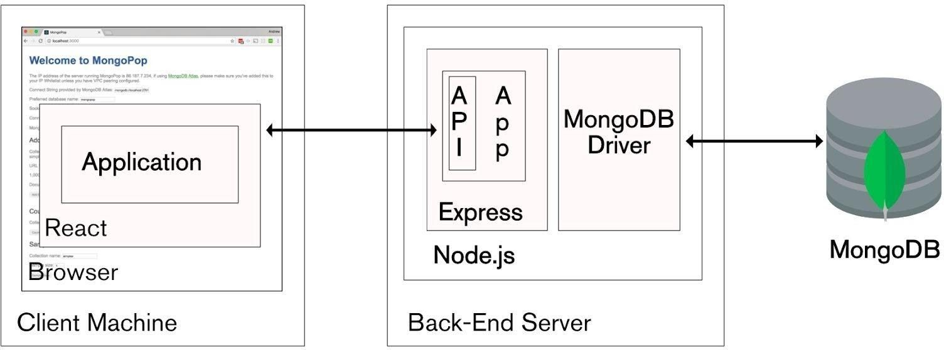

### ​Figure 1.1 ReactJS and NodeJS Workflow

**2**​

1.4 AGILE MODEL

Agile model believes that every project needs to be handled differently and the existing methods need to be tailored to best suit the project requirements. In Agile, the tasks are divided to time boxes (small time frames) to deliver specific features for a release.

1.5 DESIGN AND DEVELOPMENT

Prior to building any application from scratch, it is important to plan the design flow of the application. The user interface design is pretty essential to know how the application is intended to work. Planning an application definitely involves some specific strategies. After planning the application. Wire framing is simply designing the flow of the application,

describing how the navigation of the views will work.

After the proper flow of the app, next comes the development phase. Visual Studio Code is an IDE that is available from the Visual Studio Code website and the developers can download it to start building applications. Visual Studio Code comes with nice extensions and helps us to test the app. Software design yields three levels of results,

Architectural Design

High-level Design

Detailed Design

1.6​ CHALLENGES IN DEVELOPMENT

Not suitable for handling complex dependencies.

More risk of sustainability, maintainability and extensible to architecture the system.

Not Understanding the User preferences to clarify their needs.

Keeping up with Technology to make the system up to date.

Time estimation for calculating the future expenses level.

Security threats for accessing accounts.

Working with two algorithms embed which increase complexity.

Planning the code and architecture for better performance.

3​

1.7 ADVANTAGES OVER ALGORITHM

Installing third party package for better handling.

Agile model for better sustainable architecture.

Categorizing the users input for better understanding.

Make system as micro services to keeping up with Technology.

Single Database request to make time efficient data fetch.

Providing tokens for secure accessing of accounts.

Handling in the different ways to get the data efficiently.

Using procedures and aggregations fro better performance.

1.8​ TECHNOLOGIES AND TOOLS INVOLVED

PROGRAMMING LANGUAGE : Java script

DATABASE: MongoDB

USER INTERFACE: React and React Native, Html, Css.

TOOLS : Visual Studio Code, MongoDB Compass, Browser

4​

**CHAPTER 2**​

## SOFTWARE LEVEL DESIGN

Machine learning in finance may work magic, even though there is no magic behind it. Still, the success of machine learning project depends more on building efficient infrastructure, collecting suitable data sets, and applying the right algorithms. Machine learning is making significant inroads in the financial services industry. Let’s see why financial companies should care, what solutions they can implement will AI and Machine Learning, and how exactly they can apply this technology. Predictive analytic is a branch of advanced data analytic that involves the use of various techniques such as machine learning, statistical algorithms and other data mining techniques to forecast future events based on historical data. The Model is then applied to current data to predict what would be the next course of action or suggestions for the outcome.

2.1 LINEAR REGRESSION

Linear Regression is a machine learning algorithm based on supervised learning. It performs a regression task. Regression models a target prediction value based on independent variables. It is mostly used for finding out the relationship between variables and forecasting. Different regression models differ based on the kind of relationship between dependent and independent variables, they are considering and the number of independent variables being

used.

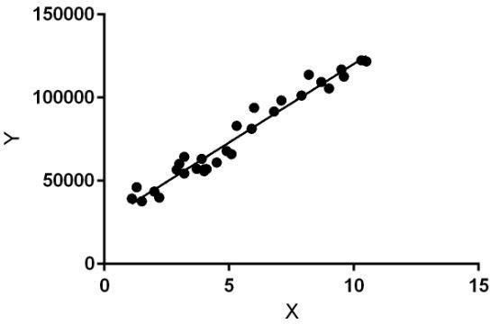

**Figure 3.1 Regression chart for Expense prediction**

​**5**

Linear regression performs the task to predict the expense for future prediction (y) based on a given expense for the month or week (x). So, this regression technique finds out a linear relationship between x (input = Expense for the Week) and y (output = Future Expense based on the given input). In the figure above, X (input) is the Expense on particular category and Y (output) is the money spent by a person. The regression line is the best fit line for our model.

### Y = θ1 + θ2.X

xis​ called input training data (one input variable(parameter) and the **y**​is​ called labels to data (supervised learning) . When training the model it fits the best line to predict the value of y for a given value of x. The model gets the best regression fit line by finding the best θ1 and θ2 values. θ1 represents the intercept, θ2 represents the coefficient of x. Once we find the best θ1 and θ2 values, we get the best fit line. So when we are finally using our model for

prediction, it will predict the value of y for the input value of x.

2.2 APRIORI ALGORITHM

All non-empty subset of frequent item set must be frequent. The key concept of Apriori algorithm is its anti monotonic of support measure. Apriori assumes that All subsets of a frequent item set must be. If an item set is infrequent, all its super sets will be infrequent. Before we start understanding the algorithm, go through some definitions which are explained in my previous post. Consider the following data set for the items purchased on this week and we will find frequent item sets and generate association rules for them.

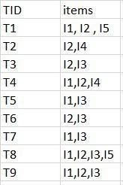

Figure 3.2 Item Data set.

6​

Minimum support count is 2. Minimum confidence is 60%

### Step-1 K=1​

1. Create a table containing support count of each item present in data set called

C1(candidate set).

### Step-2 K=2​

1. Generate candidate set C2 using L1 (this is called join step). Condition of joining

Lk-1 and Lk-1 is that it should have (K-2) elements in common.

1. Check all subsets of an item set are frequent or not and if not frequent remove that item set.

### Step-3

1. Generate candidate set C3 using L2. Condition of joining Lk-1 and Lk-1 is that it should have (K-2) elements in common. So here, for L2, first element should match.

So item set generated by joining L2 is {I1, I2, I3}{I1, I2, I5}{I1, I3, i5}{I2, I3,

I4}{I2, I4, I5}{I2, I3, I5}

1. Check if all subsets of these item sets are frequent or not and if not, then remove that item set.

**Step-4:**

1. Generate candidate set C4 using L3 (join step). Condition of joining Lk-1 and Lk-1 (K=4) is that, they should have (K-2) elements in common. So here, for L3, first 2 elements (items) should match.
2. Check all subsets of these item sets are frequent or not (Here item set formed by joining L3 is {I1, I2, I3, I5} so its subset contains {I1, I3, I5}, which is not frequent).

So no item set in C4.

Thus, we have discovered all the frequent item-sets. Now generation of strong association rule comes into the picture. For that we need to calculate confidence of each rule.

Confidence(A->B) = Support_count(A​∪​B)/Support_count(A)

7​

So here, by taking an example of any frequent item set, we will show the rule generation. Item set {I1, I2, I3}. So the rules can be given as

[I1^I2]=>[I3] //confidence =50%

[I1^I3]=>[I2] //confidence = 50%

[I2^I3]=>[I1] //confidence =50%

[I1]=>[I2^I3] //confidence =33%

[I2]=>[I1^I3] //confidence = 28%

[I3]=>[I1^I2] //confidence = 33%

2.3 REQUIREMENTS

3.3.1 FUNCTIONAL REQUIREMENTS

▪The Application must provide the facility to debit & credit transactions.

▪It should generate the overall report of expenses.

▪Example: total monthly yearly etc.

3.3.2 NON FUNCTIONAL REQUIREMENTS

▪ The system should not disclose any transactions of one user to another ▪ The business transactions should be in particular unit of currency defined by the managers.

8​

**CHAPTER 3**​

## LITERATURE SURVEY

1. **P.Thanapal,** [**Mohamme**](https://www.researchgate.net/scientific-contributions/2069136681_Mohammed_Yaseen_Patel?_sg=dNM6MzVqpACxFm2P3oXEA_yM2ZQtI7k3Qp4C6VbcGyaZXk4C8AQ8tzPzM1zem5b5OV7QG2ltYGZu4xM)**​** [**d Yaseen Patel**](https://www.researchgate.net/scientific-contributions/2069136681_Mohammed_Yaseen_Patel?_sg=dNM6MzVqpACxFm2P3oXEA_yM2ZQtI7k3Qp4C6VbcGyaZXk4C8AQ8tzPzM1zem5b5OV7QG2ltYGZu4xM)**,​** [**”**](https://www.researchgate.net/publication/273500084_Income_and_Expense_Tracker?_sg=Wl1gdsDiqTTpoZPQucMuHESB1cPEhR-eoraCTu728hnHF1XEPCm8Qaqyq1GAR65e5JOLpXgdkuR5tD4)**​**[**Incom**](https://www.researchgate.net/publication/273500084_Income_and_Expense_Tracker?_sg=Wl1gdsDiqTTpoZPQucMuHESB1cPEhR-eoraCTu728hnHF1XEPCm8Qaqyq1GAR65e5JOLpXgdkuR5tD4)[**e and Expense Tracker**](https://www.researchgate.net/publication/273500084_Income_and_Expense_Tracker?_sg=Wl1gdsDiqTTpoZPQucMuHESB1cPEhR-eoraCTu728hnHF1XEPCm8Qaqyq1GAR65e5JOLpXgdkuR5tD4)**”​ ,Indian Journal of Science and Technology, Vol 8(S2), 118–122, January 2015 in Feb 2015**

This paper they avoided Income and Expense calculations, to remind a person through android application in expense tracker they had categories like add expense, expenses of each month, add new expense, view categories of expenses, export expenses in a date range, remove export files, view categories wise expenses. To avoid Income and Expense calculations and in the same manner to remind a person, Due to some conflict or some other stress we forget some times that what are the income or where the money has to come from or what the payments we have to pay. So, develop an android

application which may helpful in all. It does not focus on single user. So user specification is focused here.

1. **Liqian , Ma,**[**Siy**](https://www.researchgate.net/scientific-contributions/2158132696_Siyu_Tang?_sg=DluGC0z4xcNe_bzTyjvEG3JERae_eXYBycUtYCwVaaw0-Q2o_RjsGLLCMD9i-7EsXSEmBFHSPeAug-s)**​** [**u , Tang**](https://www.researchgate.net/scientific-contributions/2158132696_Siyu_Tang?_sg=DluGC0z4xcNe_bzTyjvEG3JERae_eXYBycUtYCwVaaw0-Q2o_RjsGLLCMD9i-7EsXSEmBFHSPeAug-s)[**,**](https://www.researchgate.net/scientific-contributions/2158120515_Michael_J_Black?_sg=8XZ8TJQL0q1TxFoz-0Vmdm0YnEMUe6FyVkWmiwfvHkyRz-YjUY1fatU0lljfW7yrBsMIw-500fl1WYY)**​** [**Michae**](https://www.researchgate.net/scientific-contributions/2158120515_Michael_J_Black?_sg=8XZ8TJQL0q1TxFoz-0Vmdm0YnEMUe6FyVkWmiwfvHkyRz-YjUY1fatU0lljfW7yrBsMIw-500fl1WYY)**​** [**l , J. Black,**](https://www.researchgate.net/scientific-contributions/2158120515_Michael_J_Black?_sg=8XZ8TJQL0q1TxFoz-0Vmdm0YnEMUe6FyVkWmiwfvHkyRz-YjUY1fatU0lljfW7yrBsMIw-500fl1WYY)**​ “**[**Customize**](https://www.researchgate.net/publication/333549772_Customized_Multi-person_Tracker?_sg=ji9peKPXWgNhD6MphtmOdIm96eXcnBAVojO3Vm8dBUF4diRcLyx7IQ4G4Nyevk9KKdAdpMXLTLZSOjU)**​** [**d Multi-person Tracker**](https://www.researchgate.net/publication/333549772_Customized_Multi-person_Tracker?_sg=ji9peKPXWgNhD6MphtmOdIm96eXcnBAVojO3Vm8dBUF4diRcLyx7IQ4G4Nyevk9KKdAdpMXLTLZSOjU)**”​ ,Springer International** **Publishing Asian Conference on Computer Vision Perth, in Jun 2019**

The task of multi-person tracking in crowded street scenes, where long-term occlusions pose a major challenge. This challenge was to re-identify people before and after occlusions using Convolutional Neural Networks (CNNs). CNNs require a large amount of training data, which was not available for multi-person tracking scenarios. A few high-quality training examples that are automatically mined from the test sequence can be used to fine-tune pre-trained CNNs. To that end, we introduce a hierarchical correlation clustering (HCC) framework. This paper focus on how to generate the high-quality training examples for customizing the person re-identification CNNs. Does not focus on Expense Future Prediction. So, Prediction is done by Machine learning Algorithm.

9

**3. Sangwon , Park,**[**Mina , Woo**](https://www.researchgate.net/scientific-contributions/2118843033_Mina_Woo?_sg=kZOZLu2Ca-81KN720jEVRtqj9qeIcL86q6aRLIXxNG7tOEPCuWyNHoI3Q7AKjuW-2F3m551yJDXKnhM)**,**[**Juan , L. Nicolau**](https://www.researchgate.net/profile/Juan_Nicolau2?_sg=K685kjVVMEOsvbaRHU0SnIUTkYiYUteX9DHO9gOKzq1ty4H-nnLfWRNbCKWA3xof9k0HQwP1KMY-S-g)**,”**[**Determinant Factors of Tourist Expenses**](https://www.researchgate.net/publication/331293396_Determinant_Factors_of_Tourist_Expenses?_sg=WWnUzW-Sp1oZ7rv7Q0NZoaVtW5gdKFKl8SJxjpDKJuroH8hMubYTX3dixn6qD-gALpoABwARu4-iawM)**” , School of Hotel and Tourism Management, The Hong Kong Polytechnic University, Kowloon, Hong Kong in Feb 2019**

Analyzed travel expenses across and within types. The empirical application examined the determinant factors of total expenses, controlling for potential endogeneity, and relies on quantile regression to analyse the effects of information search behaviour on the distribution of

total expenses as well as accommodation, shopping, food and beverages, and local transportation expenses. The role of information sources in predicting travel spending behaviour was a new dimension in the literature on expenses, as well as theoretical implications. Only focus on Travel Expenses, Can be included with Expense tracking for day to day expenses.

**4. Michael Kerbar, ”Metric​ spaces with Expensive Distances”,​ Graz University of Technology institute for Geometric Austria in Jan 2019**

A model where they assumed that the computation of a single distance was an expensive operation and consequently, the goal was to minimize the number of such distance queries. This model was motivated by metric spaces that appear in the context of topological data analysis. In both cases, we partially explore the metric space through distance queries and infer

lower and upper bounds for yet unexplored distances through triangle inequality. They evaluate several exploration strategies through extensive experimental evaluation. the computation of an approximate nearest neighbor for a given query point. In both cases, we partially explore the metric space through distance queries and infer lower and upper bounds for yet unexplored distances through triangle inequality. For spanners, we evaluate several exploration strategies through extensive experimental evaluation. For approximate nearest neighbors, we prove that our strategy returns an approximate nearest neighbor after a logarithmic number of distance queries. Does not focus on the expense pattern in real life, So Implementing algorithm for predicting pattern.

10

**5. D**[**esmon**](https://www.researchgate.net/profile/Desmond_Bartholomew?_sg=dPHBhHEmeZFpK2bhUEzGSkhZPhD_0_A4uEYruO8xawq9dOar-fHSjvoaIpsA-kBhDw7P8FG226hUeNY)**​** [**d Chekwube Bartholomew**](https://www.researchgate.net/profile/Desmond_Bartholomew?_sg=dPHBhHEmeZFpK2bhUEzGSkhZPhD_0_A4uEYruO8xawq9dOar-fHSjvoaIpsA-kBhDw7P8FG226hUeNY)**,”​** [**Incom**](https://www.researchgate.net/publication/330578235_Income_Expenses_Calculator?_sg=Jfx-80BeJYXSw39ptE9TYd6i5JKF0Mzaq_8YdSr6rMBgi3dJrxlyIckClW4_qCr5HhTJ3OjyHh0IORU)**​**[**e & Expenses Calculator**](https://www.researchgate.net/publication/330578235_Income_Expenses_Calculator?_sg=Jfx-80BeJYXSw39ptE9TYd6i5JKF0Mzaq_8YdSr6rMBgi3dJrxlyIckClW4_qCr5HhTJ3OjyHh0IORU)**”​** [**Federal University of Technology Owerri. Department of Statistics**](https://www.researchgate.net/institution/Federal_University_of_Technology_Owerri) **Bachelor of Technology in Jan 2019**

The income and expenses calculator required users to input daily expenses which in turn

would be compared against user inputted monthly pay. To avoid Income and Expense calculations and in the same manner to remind a person, we develop an android application which may helpful in all Simple Calculator functionality, the situations and it can be installed in our android phones. It help us to remind and add some information that what are the income comes from other persons and what are all the expenses or payments. So, Using complex algorithm for better performance.

**6.** [**Moh**](https://www.researchgate.net/scientific-contributions/2158693610_Mohd_Saifuddin?_sg=AIjPSuYOjLb0vyDQTHJKtycul_-Meh-AKlJT64wPMr3_XT62nz3exzNlEgebCw_HB2CgvXHXzLhgxGg)**​** [**d Saifuddin**](https://www.researchgate.net/scientific-contributions/2158693610_Mohd_Saifuddin?_sg=AIjPSuYOjLb0vyDQTHJKtycul_-Meh-AKlJT64wPMr3_XT62nz3exzNlEgebCw_HB2CgvXHXzLhgxGg) **,** [**Reeha**](https://www.researchgate.net/profile/Reehan_Lalkhanwar?_sg=5U3PkdYG1pUPy4elVuu0XM4DQmiPmzwzEwkCOVtOnt_AEGmsUnwXha-t0guQBsQ7e827YOp8N0hOLA4)**​** [**n A. K. Lal Kanwar**](https://www.researchgate.net/profile/Reehan_Lalkhanwar?_sg=5U3PkdYG1pUPy4elVuu0XM4DQmiPmzwzEwkCOVtOnt_AEGmsUnwXha-t0guQBsQ7e827YOp8N0hOLA4)**,”​ ​**[**Expense Based Performance Assessment Of Financial Institution**](https://www.researchgate.net/publication/333816960_Expense_Based_Performance_Assessment_Of_Financial_Institution?_sg=GcSpf9y2REUDCeId3xj-ZHEraMAFfVlyf8-Wde1D6xf-lkYCpaBSiNvy0-i6ivrueiyH706LnfdOwRE)**”,​ Saifuddin Mohd et al.; International Journal of Advance Research, Ideas and Innovations in Technology in Jun 2019**

A scientific cost distribution value that named as the Expense Accrual Ratio (EAR), along with the other parameters of measurement, EAR can be used to assess the health of a financial institution. The role and functioning of EAR along with ways of calculation of it with formulas for the derivation was explained. Further, its impact on performance was analysed with data references. Comparison is done with the current interest rates of the institution to derive at a conclusion based on EAR. Along with other parameters of the measure this can be used as a powerful tool to adjust the functioning of the financial institution to avoid further losses. Basedon Financial institute expense only. Including daily expenses along with the

financial institution expense.

11

1. [**Ja**](https://www.researchgate.net/profile/Jan_Bewersdorf?_sg=oPcWpQ1kt1tXrYR-dJo_R2vFxENL3eGzfyp6lSUvf6PjAy26uFQQuQbkaFh-6NRin7uXr5JvCIsoXX0)**​** [**n Philipp Bewersdorf**](https://www.researchgate.net/profile/Jan_Bewersdorf?_sg=oPcWpQ1kt1tXrYR-dJo_R2vFxENL3eGzfyp6lSUvf6PjAy26uFQQuQbkaFh-6NRin7uXr5JvCIsoXX0) **,** [**Ror**](https://www.researchgate.net/profile/Rory_Shallis?_sg=MBP1Km6D6HpCsWAV2qKf4-hm0sLczGdQD12kOt4NXdAJ6Ko1PWXUxArRlsCb7YT3-FehKNCyZCsVqcQ)**​** [**y M. Shallis,**](https://www.researchgate.net/profile/Rory_Shallis?_sg=MBP1Km6D6HpCsWAV2qKf4-hm0sLczGdQD12kOt4NXdAJ6Ko1PWXUxArRlsCb7YT3-FehKNCyZCsVqcQ)**​ ”**[**Healt**](https://www.researchgate.net/publication/333608333_Health_care_expenses_for_treatment_of_acute_myeloid_leukemia?_sg=th-oDRxz_L0E1pbN5n6WGythONltfHueY0JMvDQCwDOcSpa2HyNb9A70CYjSjXJSU3tfpeUjOe-Qtfo)**​** [**h care expenses for treatment of acute myeloid leukemia”**](https://www.researchgate.net/publication/333608333_Health_care_expenses_for_treatment_of_acute_myeloid_leukemia?_sg=th-oDRxz_L0E1pbN5n6WGythONltfHueY0JMvDQCwDOcSpa2HyNb9A70CYjSjXJSU3tfpeUjOe-Qtfo)**​ , department of internal mediciene school,in Jun 2019 .**

An overview of the healthcare costs in patients with AML treated with various modalities. The authors reviewed both the impact of the recently approved novel AML agents and an increasingly personalized treatment approach on healthcare resources. The direct healthcare costs of AML are substantial and vary depending on the treatment approach. Treatment costs have increased out of proportion to general inflation and this trend is likely

going to continue or even accelerate. Advanced treatment expenses are not predicted.

Future prediction is done using machine learning algorithm.

1. **Girish Bekaroo and Sameer Sunhaloo,”Intelligent​ Online Budget Tracker”​**

**School of Business Informatics and Software Engineering, University of Technology, Mauritius in October 2007**

We present an intelligent online budget tracker to efficiently manage household budget.

Our system will help to plan and track household-budget related issues where members of the system can securely access it anytime from anywhere via the Internet. The Intelligent Online Budget Tracker not only keeps track of the budget but also provides means to analyze data via charts and graphs as well as intelligently predicting future budgets and issues like bankruptcy.Budgeting also requires us to look ahead and formalize future goals. By

establishing a budget, people can set goals for achieving a certain level of income and monitor their expenses. Many home based and small-business owners have observed that their increase in profit margins did not occur until they had a written revenue goal and a method with which to monitor expenses.Only focused on calculation but does not focus on accuracy level to be certain.

12​

**CHAPTER 4**​

## ARCHITECTURE DIAGRAM

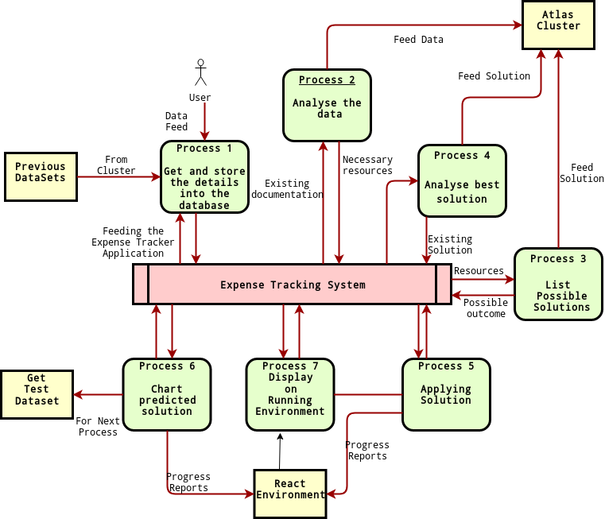

**Figure 6.1 Architecture Diagram**

**13**​

## SEQUENCE DIAGRAM

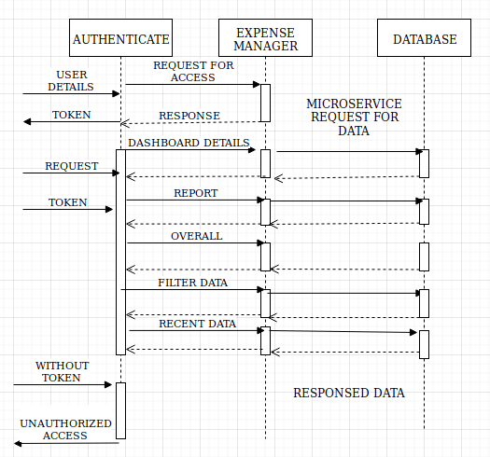

14

## USE CASE DIAGRAM

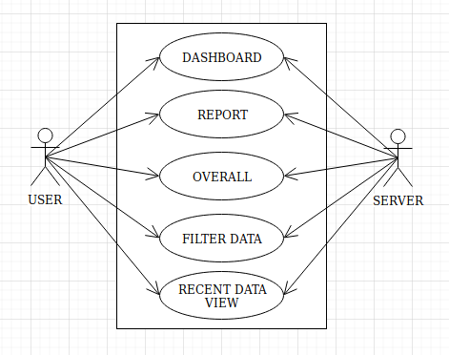

**Figure 6.3 Use case Diagram**

15​

## USER INTERFACE

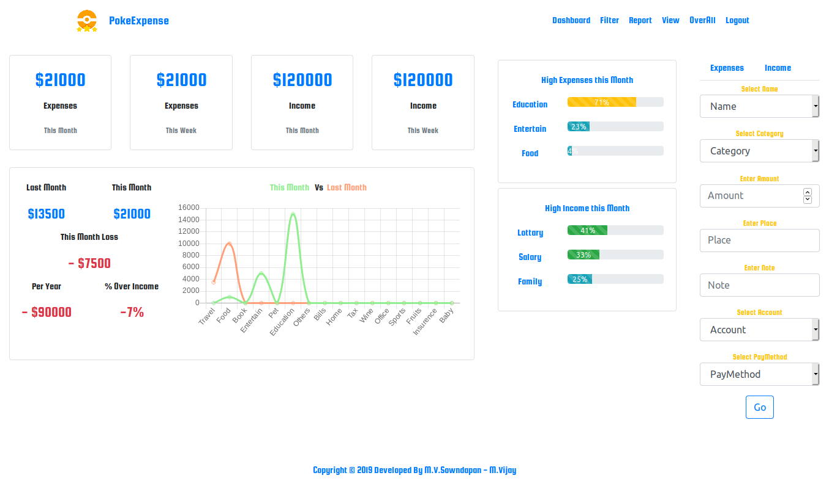

**Figure 6.4 Mobile View**

## CHARTS USED FOR REPRESENTING REPORTS

Histogram.

Bar chart.

Pie chart.

Line chart.

16​

## LAP TOP VIEW

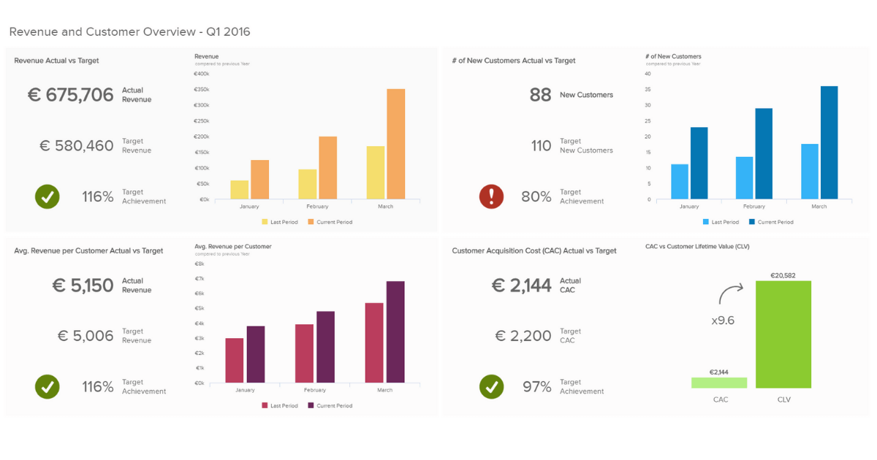

**Figure 6.5 Lap Top View**

## PACKAGES USED FOR DESIGNING USER INTERFACE

ChartJS

BootStrap

Jquery

17​

# CHAPTER 5

# REFERENCES

1. P.Thanapal, [Mohamme](https://www.researchgate.net/scientific-contributions/2069136681_Mohammed_Yaseen_Patel?_sg=dNM6MzVqpACxFm2P3oXEA_yM2ZQtI7k3Qp4C6VbcGyaZXk4C8AQ8tzPzM1zem5b5OV7QG2ltYGZu4xM)​ [d Yaseen Patel](https://www.researchgate.net/scientific-contributions/2069136681_Mohammed_Yaseen_Patel?_sg=dNM6MzVqpACxFm2P3oXEA_yM2ZQtI7k3Qp4C6VbcGyaZXk4C8AQ8tzPzM1zem5b5OV7QG2ltYGZu4xM),​ [”Incom](https://www.researchgate.net/publication/273500084_Income_and_Expense_Tracker?_sg=Wl1gdsDiqTTpoZPQucMuHESB1cPEhR-eoraCTu728hnHF1XEPCm8Qaqyq1GAR65e5JOLpXgdkuR5tD4)​ [e and Expense Tracker](https://www.researchgate.net/publication/273500084_Income_and_Expense_Tracker?_sg=Wl1gdsDiqTTpoZPQucMuHESB1cPEhR-eoraCTu728hnHF1XEPCm8Qaqyq1GAR65e5JOLpXgdkuR5tD4)”​ ,Indian Journal of Science and Technology, Vol 8(S2), 118–122, January 2015 in Feb 2015
2. Liqian , Ma,[Siy](https://www.researchgate.net/scientific-contributions/2158132696_Siyu_Tang?_sg=DluGC0z4xcNe_bzTyjvEG3JERae_eXYBycUtYCwVaaw0-Q2o_RjsGLLCMD9i-7EsXSEmBFHSPeAug-s)​ [u , Tang,](https://www.researchgate.net/scientific-contributions/2158132696_Siyu_Tang?_sg=DluGC0z4xcNe_bzTyjvEG3JERae_eXYBycUtYCwVaaw0-Q2o_RjsGLLCMD9i-7EsXSEmBFHSPeAug-s)​ [Michae](https://www.researchgate.net/scientific-contributions/2158120515_Michael_J_Black?_sg=8XZ8TJQL0q1TxFoz-0Vmdm0YnEMUe6FyVkWmiwfvHkyRz-YjUY1fatU0lljfW7yrBsMIw-500fl1WYY)​ [l , J. Black](https://www.researchgate.net/scientific-contributions/2158120515_Michael_J_Black?_sg=8XZ8TJQL0q1TxFoz-0Vmdm0YnEMUe6FyVkWmiwfvHkyRz-YjUY1fatU0lljfW7yrBsMIw-500fl1WYY)​[,](https://www.researchgate.net/scientific-contributions/2158120515_Michael_J_Black?_sg=8XZ8TJQL0q1TxFoz-0Vmdm0YnEMUe6FyVkWmiwfvHkyRz-YjUY1fatU0lljfW7yrBsMIw-500fl1WYY) “[Customize](https://www.researchgate.net/publication/333549772_Customized_Multi-person_Tracker?_sg=ji9peKPXWgNhD6MphtmOdIm96eXcnBAVojO3Vm8dBUF4diRcLyx7IQ4G4Nyevk9KKdAdpMXLTLZSOjU)​ [d Multi-person Tracker](https://www.researchgate.net/publication/333549772_Customized_Multi-person_Tracker?_sg=ji9peKPXWgNhD6MphtmOdIm96eXcnBAVojO3Vm8dBUF4diRcLyx7IQ4G4Nyevk9KKdAdpMXLTLZSOjU)”​ ,Springer International Publishing Asian Conference on Computer Vision Perth, in Jun 2019
3. Sangwon , Park,[Min](https://www.researchgate.net/scientific-contributions/2118843033_Mina_Woo?_sg=kZOZLu2Ca-81KN720jEVRtqj9qeIcL86q6aRLIXxNG7tOEPCuWyNHoI3Q7AKjuW-2F3m551yJDXKnhM)​ [a , Woo](https://www.researchgate.net/scientific-contributions/2118843033_Mina_Woo?_sg=kZOZLu2Ca-81KN720jEVRtqj9qeIcL86q6aRLIXxNG7tOEPCuWyNHoI3Q7AKjuW-2F3m551yJDXKnhM)[,](https://www.researchgate.net/profile/Juan_Nicolau2?_sg=K685kjVVMEOsvbaRHU0SnIUTkYiYUteX9DHO9gOKzq1ty4H-nnLfWRNbCKWA3xof9k0HQwP1KMY-S-g)​ [Jua](https://www.researchgate.net/profile/Juan_Nicolau2?_sg=K685kjVVMEOsvbaRHU0SnIUTkYiYUteX9DHO9gOKzq1ty4H-nnLfWRNbCKWA3xof9k0HQwP1KMY-S-g)​ [n , L. Nicolau,](https://www.researchgate.net/profile/Juan_Nicolau2?_sg=K685kjVVMEOsvbaRHU0SnIUTkYiYUteX9DHO9gOKzq1ty4H-nnLfWRNbCKWA3xof9k0HQwP1KMY-S-g)​ ”[Determinan](https://www.researchgate.net/publication/331293396_Determinant_Factors_of_Tourist_Expenses?_sg=WWnUzW-Sp1oZ7rv7Q0NZoaVtW5gdKFKl8SJxjpDKJuroH8hMubYTX3dixn6qD-gALpoABwARu4-iawM)​ [t Factors of Tourist Expenses”](https://www.researchgate.net/publication/331293396_Determinant_Factors_of_Tourist_Expenses?_sg=WWnUzW-Sp1oZ7rv7Q0NZoaVtW5gdKFKl8SJxjpDKJuroH8hMubYTX3dixn6qD-gALpoABwARu4-iawM)​ , School of Hotel and Tourism Management, The Hong Kong Polytechnic University, Kowloon, Hong Kong in Feb 2019
4. Michael Kerbar, ”**Metric**​ **spaces with Expensive Distances**”,​ Graz University of Technology institute for Geometric Austria in Jan 2019

5.D[esmon](https://www.researchgate.net/profile/Desmond_Bartholomew?_sg=dPHBhHEmeZFpK2bhUEzGSkhZPhD_0_A4uEYruO8xawq9dOar-fHSjvoaIpsA-kBhDw7P8FG226hUeNY)​ [d Chekwube Bartholomew](https://www.researchgate.net/profile/Desmond_Bartholomew?_sg=dPHBhHEmeZFpK2bhUEzGSkhZPhD_0_A4uEYruO8xawq9dOar-fHSjvoaIpsA-kBhDw7P8FG226hUeNY),”​ [**Incom**](https://www.researchgate.net/publication/330578235_Income_Expenses_Calculator?_sg=Jfx-80BeJYXSw39ptE9TYd6i5JKF0Mzaq_8YdSr6rMBgi3dJrxlyIckClW4_qCr5HhTJ3OjyHh0IORU)​ [**e & Expenses Calculator**](https://www.researchgate.net/publication/330578235_Income_Expenses_Calculator?_sg=Jfx-80BeJYXSw39ptE9TYd6i5JKF0Mzaq_8YdSr6rMBgi3dJrxlyIckClW4_qCr5HhTJ3OjyHh0IORU)”​ [Federa](https://www.researchgate.net/institution/Federal_University_of_Technology_Owerri)​ [l University](https://www.researchgate.net/institution/Federal_University_of_Technology_Owerri)

[of Technology Owerri. Department of Statistics](https://www.researchgate.net/institution/Federal_University_of_Technology_Owerri) Bachelor of Technology in Jan 2019​

* 1. [Moh](https://www.researchgate.net/scientific-contributions/2158693610_Mohd_Saifuddin?_sg=AIjPSuYOjLb0vyDQTHJKtycul_-Meh-AKlJT64wPMr3_XT62nz3exzNlEgebCw_HB2CgvXHXzLhgxGg)​ [d Saifuddin](https://www.researchgate.net/scientific-contributions/2158693610_Mohd_Saifuddin?_sg=AIjPSuYOjLb0vyDQTHJKtycul_-Meh-AKlJT64wPMr3_XT62nz3exzNlEgebCw_HB2CgvXHXzLhgxGg) , [Reeha](https://www.researchgate.net/profile/Reehan_Lalkhanwar?_sg=5U3PkdYG1pUPy4elVuu0XM4DQmiPmzwzEwkCOVtOnt_AEGmsUnwXha-t0guQBsQ7e827YOp8N0hOLA4)​ [n A. K. Lal Kanwar,](https://www.researchgate.net/profile/Reehan_Lalkhanwar?_sg=5U3PkdYG1pUPy4elVuu0XM4DQmiPmzwzEwkCOVtOnt_AEGmsUnwXha-t0guQBsQ7e827YOp8N0hOLA4)​ ”[**Expens**](https://www.researchgate.net/publication/333816960_Expense_Based_Performance_Assessment_Of_Financial_Institution?_sg=GcSpf9y2REUDCeId3xj-ZHEraMAFfVlyf8-Wde1D6xf-lkYCpaBSiNvy0-i6ivrueiyH706LnfdOwRE)​ [**e Based Performance Assessment Of Financial Institution**](https://www.researchgate.net/publication/333816960_Expense_Based_Performance_Assessment_Of_Financial_Institution?_sg=GcSpf9y2REUDCeId3xj-ZHEraMAFfVlyf8-Wde1D6xf-lkYCpaBSiNvy0-i6ivrueiyH706LnfdOwRE)”,​ Saifuddin Mohd et al.; International Journal of Advance Research, Ideas and Innovations in Technology in Jun 2019
  2. [Simo](https://www.researchgate.net/scientific-contributions/2158474199_Simon_Besenthal?_sg=nSLuotl41uWVQRXrr2mMSZPJisrRXsUkNNXANv7aPfy90gH_wHq75xeGGphAZ2JkTNWWJv_8JFUDxZE)​ [n Besenthal](https://www.researchgate.net/scientific-contributions/2158474199_Simon_Besenthal?_sg=nSLuotl41uWVQRXrr2mMSZPJisrRXsUkNNXANv7aPfy90gH_wHq75xeGGphAZ2JkTNWWJv_8JFUDxZE) , [Tim](https://www.researchgate.net/scientific-contributions/2150183882_Timo_Ropinski?_sg=yH9prjAlw-U3VdHrklVDj7vPkD91W1QlS70UzAYVd1VKlwXEQr5zqMvWdB5So6MXcW2wU6XgFaQDtHQ)​ [o Ropinski,](https://www.researchgate.net/scientific-contributions/2150183882_Timo_Ropinski?_sg=yH9prjAlw-U3VdHrklVDj7vPkD91W1QlS70UzAYVd1VKlwXEQr5zqMvWdB5So6MXcW2wU6XgFaQDtHQ)​ ” [**Multi-Resolutio**](https://www.researchgate.net/publication/333717622_Multi-Resolution_Rendering_for_Computationally_Expensive_Lighting_Effects?_sg=svWoOBn_kyMpDFnPJ3bkWCi8c_XPXBdhDd4NDxdrRWI8DfyiuCw8FYW9fNZROme5RLZJghhZgf2laF4)​ [**n Rendering for Computationally Expensive Lighting Effects**](https://www.researchgate.net/publication/333717622_Multi-Resolution_Rendering_for_Computationally_Expensive_Lighting_Effects?_sg=svWoOBn_kyMpDFnPJ3bkWCi8c_XPXBdhDd4NDxdrRWI8DfyiuCw8FYW9fNZROme5RLZJghhZgf2laF4)”,ulm universzity in Jun 2019.​
  3. by [Ja](https://www.researchgate.net/profile/Jan_Bewersdorf?_sg=oPcWpQ1kt1tXrYR-dJo_R2vFxENL3eGzfyp6lSUvf6PjAy26uFQQuQbkaFh-6NRin7uXr5JvCIsoXX0)​ [n Philipp Bewersdorf](https://www.researchgate.net/profile/Jan_Bewersdorf?_sg=oPcWpQ1kt1tXrYR-dJo_R2vFxENL3eGzfyp6lSUvf6PjAy26uFQQuQbkaFh-6NRin7uXr5JvCIsoXX0) , [Ror](https://www.researchgate.net/profile/Rory_Shallis?_sg=MBP1Km6D6HpCsWAV2qKf4-hm0sLczGdQD12kOt4NXdAJ6Ko1PWXUxArRlsCb7YT3-FehKNCyZCsVqcQ)​ [y M. Shallis](https://www.researchgate.net/profile/Rory_Shallis?_sg=MBP1Km6D6HpCsWAV2qKf4-hm0sLczGdQD12kOt4NXdAJ6Ko1PWXUxArRlsCb7YT3-FehKNCyZCsVqcQ),”​ ​[**Health care expenses for treatment of acute myeloid leukemia**](https://www.researchgate.net/publication/333608333_Health_care_expenses_for_treatment_of_acute_myeloid_leukemia?_sg=th-oDRxz_L0E1pbN5n6WGythONltfHueY0JMvDQCwDOcSpa2HyNb9A70CYjSjXJSU3tfpeUjOe-Qtfo)”, department of internal mediciene school in Jun 2019​
  4. [Ja](https://www.researchgate.net/profile/Jan_Bewersdorf?_sg=oPcWpQ1kt1tXrYR-dJo_R2vFxENL3eGzfyp6lSUvf6PjAy26uFQQuQbkaFh-6NRin7uXr5JvCIsoXX0)​ [n Philipp Bewersdorf](https://www.researchgate.net/profile/Jan_Bewersdorf?_sg=oPcWpQ1kt1tXrYR-dJo_R2vFxENL3eGzfyp6lSUvf6PjAy26uFQQuQbkaFh-6NRin7uXr5JvCIsoXX0) , [Ror](https://www.researchgate.net/profile/Rory_Shallis?_sg=MBP1Km6D6HpCsWAV2qKf4-hm0sLczGdQD12kOt4NXdAJ6Ko1PWXUxArRlsCb7YT3-FehKNCyZCsVqcQ)​ [y M. Shallis](https://www.researchgate.net/profile/Rory_Shallis?_sg=MBP1Km6D6HpCsWAV2qKf4-hm0sLczGdQD12kOt4NXdAJ6Ko1PWXUxArRlsCb7YT3-FehKNCyZCsVqcQ),”​ [**Healt**](https://www.researchgate.net/publication/333608333_Health_care_expenses_for_treatment_of_acute_myeloid_leukemia?_sg=th-oDRxz_L0E1pbN5n6WGythONltfHueY0JMvDQCwDOcSpa2HyNb9A70CYjSjXJSU3tfpeUjOe-Qtfo)​ [**h care expenses for treatment of acute myeloid leukemia**”](https://www.researchgate.net/publication/333608333_Health_care_expenses_for_treatment_of_acute_myeloid_leukemia?_sg=th-oDRxz_L0E1pbN5n6WGythONltfHueY0JMvDQCwDOcSpa2HyNb9A70CYjSjXJSU3tfpeUjOe-Qtfo)​ , department of internal mediciene school,in Jun 2019 .

1. [Sebastia](https://www.researchgate.net/profile/Sebastian_Gallenmueller?_sg=sns7kAwVaOL2zabLfe2POzPW8hstSMtpiF3fu2uU4r7ttC0HngF7fm78TNaChg229MfGvWEkjLVSMyE)​ [n Gallenmüller](https://www.researchgate.net/profile/Sebastian_Gallenmueller?_sg=sns7kAwVaOL2zabLfe2POzPW8hstSMtpiF3fu2uU4r7ttC0HngF7fm78TNaChg229MfGvWEkjLVSMyE) , [Domini](https://www.researchgate.net/scientific-contributions/2156478601_Dominik_Schoeffmann?_sg=H6dfnNwprWrvxcB2_JV4tLKsYddEL2iDjKcU-ssMcHhkOAbyoexdUwPfjvBjzy3hwswtBhcynWqpbjM)​ [k Schöffmann](https://www.researchgate.net/scientific-contributions/2156478601_Dominik_Schoeffmann?_sg=H6dfnNwprWrvxcB2_JV4tLKsYddEL2iDjKcU-ssMcHhkOAbyoexdUwPfjvBjzy3hwswtBhcynWqpbjM),”​ ​[**DTLS Performance - How Expensive is**](https://www.researchgate.net/publication/332669608_DTLS_Performance_-_How_Expensive_is_Security?_sg=zQ7iG5wnvZ7qiWXfAX2XZRLAZMmfWRcXXrOES0kJlEw4q0hUTr35HBC2PRNGA0S53pdZsfBP-O02SZY)  [**Security?**](https://www.researchgate.net/publication/332669608_DTLS_Performance_-_How_Expensive_is_Security?_sg=zQ7iG5wnvZ7qiWXfAX2XZRLAZMmfWRcXXrOES0kJlEw4q0hUTr35HBC2PRNGA0S53pdZsfBP-O02SZY)”​ Chair of Network Architectures and Services Department of,Technical University of Munich,Garching near Munich, Bavaria, Germany in Apr 2019
2. Girish Bekaroo and Sameer Sunhaloo,”**Intelligent**​ **Online Budget Tracker**”​ School of Business Informatics and Software Engineering, University of Technology, Mauritius in

October 2007.